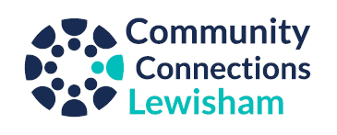

 | Dancing for Health
Organisation | Trinity Laban
Address | Laban Building, 30 Creekside, London SE8 3DZ
Description | Dancing for Health is a free, weekly dance class for people who are recovering from, or living with an acquired brain injury or stroke.  This creative dance activity is delivered by a Trinity Laban dance artist, working in collaboration with an occupational therapist. The class aims to improve wellbeing, balance, and movement capabilities. Participants can enjoy moving and dancing in a safe and supportive environment.
Who can attend? | Any adult recovering from, or living with an acquired brain injury or stroke. No previous dance experience necessary
Price | FREE
Accessibility | ☒ Step free access  ☒ Accessible toilet  ☐ Stepped access (one to three steps)  ☐ Upstairs (no lift)  ☒ Option to do the activity sitting down  The activity and building are completely accessible
Day and Time | Fridays 2-4pm, during term time  Autumn 2023 term dates: Friday 22 September – Friday 1 December
Transport | Train: The nearest rail is Deptford or Deptford Bridge, or Cutty Sark DLR.  Bus: from Lewisham to Wavelengths stop on Creekside: 47  Car: There are limited parking spaces at Trinity Laban. Participants/carers will need to email car registration in advance
Phone | Kara: 020 8305 9414
Email | Laura Woods: l.woods@trinitylaban.ac.uk
Website | https://www.trinitylaban.ac.uk/take-part/for-adults/dancing-for-health/
Joining | Advanced booking is required  A participant information form will need to be completed before attending a session
Possibility for the client to be contacted by the organiser in advance to encourage attendance | A member of the Trinity Laban team will contact the participant and/or carer prior to their first class to ensure that we have a completed information form and to answer any questions they may have.

Last updated on: 6/8/2023
If some of the information on this document is no longer accurate, please inform Community Connections Lewisham via email communityconnections@ageuklands.org.uk or on 0330 058 3464.

